Computer Programming - World's Hardest Game – Location and Size Verification

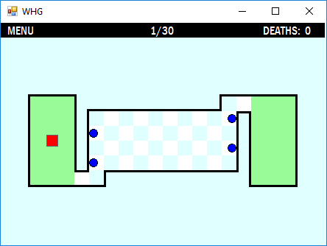

Wall1

Wall16

For each of the objects, provide the Size and Location of the object.

Object | Location (X, Y) | Size (W, H) |  | Object | Location (X, Y) | Size (W, H)
Ball1 (top) |  |  |  | Ball2
Ball3 |  |  |  | Ball4
Green Start |  |  |  | Red Box
Green End |  |  |  | Menu Label
1/30 Label |  |  |  | Deaths Label

For each of the walls that outlines the playing area of the form, provide their Size and Location. We consider the top wall above the green starting label as Wall1 (as shown above). Wall2 will be the next wall as we rotate clockwise around the form. Thus, Wall16 will be the wall on the left side of the green starting label

Object | Location (X, Y) | Size (W, H) |  | Object | Location (X, Y) | Size (W, H)
Wall1 |  |  |  | Wall9
Wall2 |  |  |  | Wall10
Wall3 |  |  |  | Wall11
Wall4 |  |  |  | Wall12
Wall5 |  |  |  | Wall13
Wall6 |  |  |  | Wall14
Wall7 |  |  |  | Wall15
Wall8 |  |  |  | Wall16

