Computer Programming - World's Hardest Game – Design Phase
60 Points

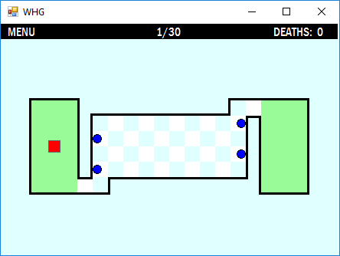

Design Details

- The entire board, with menu at top should be 22 x 17.
- The Form size is (456, 378). We assume a 16 pixel offset horizontally and 38 vertically.
- You want to create a board that is identical to the actual game. (Picture shown above)
- Using provided graph paper, plan out the exact location of the various labels that will occupy the form.
- Reserve the first row of your graph paper for the Menu. (Black bar that shows Level, Deaths)
- Use an 18 x 6 block of your graph paper to design the maze part of your game.
- Maze part should be centered vertically and horizontally on the board.
- Calculate each square on your graph paper as a 20 pixel by 20 pixel area.
- The moveable red block is 16 x 16. This give a 2 pixel “buffer” on each side of the block.
- The outside of the maze uses a separate 3 pixel (wide or tall) label to outline the boundaries of the maze.
- The checkerboard pattern on the middle part of the maze is built with several labels of alternating backcolors.
- Outlined walls should be added last.
- The four blue balls are size (12, 12). The top and 3rd ball should start against the left side of the game board.
- The bottom and 2nd ball should start on the right side of the game board.

Name:

World’s Hardest Game – Graph Paper Design

Tips

- Label your X and Y axes. Write the 20 pixel increments on each line, both vertically (Y) and horizontally (X).
- Make sure you are centering the maze part AFTER the first row.

Object Checklist- All of these objects should be drawn on your form.

Black Menu Background - Three Menu Labels – (Menu, 1/30, Deaths: 0) -

2 Green Labels (Start and End areas) - 16 Black walls (Outside the board’s playable area) -

Red Label – (Box controlled by player) - Four Ball Pictureboxes –

44 Checkerboard Labels – (background of the non-green part of maze) -

