Visual Basic Drawing Commands (Graphics Class)
In order to draw on a form, you must first create a graphics object through the form's Paint Event
- First, create the Form1_Paint event using the Dropdown boxes on the Coding page.
- Then add the two lines of code shown below, which creates the Graphics object (g).

All of your drawing command will follow this code in your Form1_Paint event.
Helpful Hint/Reminders
1. All objects are draw from back to front, so the last object you draw will appear on top of all others, if they overlap.
2. Coordinates are based on point (0,0) being the upper left hand corner of the form.

Pens - Pens are used to draw shape outlines. You can specify the color and the width of the pen when you declare it.
- Dim p2 As New Pen(Color.Black, 1)- Create a black pen that will draw thin black lines
- Dim p As New Pen(Color.Blue, 3)- Creates a pen that will draw thicker blue lines

Brushes - Brushes are used to draw Filled Shapes. You specify the color of the Brush when you declare it.
Dim blueBrush As New SolidBrush(Color.Blue)

Draw Commands- All commands that start with Draw will use Pens. Assume pen is a Pen object.

g.DrawLine (pen, X1, Y1, X2, Y2) - Draws a line from point (X1, Y1) to point (X2, Y2).
Ex: g.DrawLine(pen, 0, 0, 100, 100)

g.DrawRectangle(pen, X, Y, Width, Height) - Draws a rectangle at location(X, Y) with dimensions(width, height)
Ex: g.DrawRectangle(pen, 20, 50, 170, 100)

g.DrawEllipse(pen, X, Y, Width, Height) - Draws a circle or oval using same parameters as rectangle
Ex: g.DrawEllipse(pen, 20, 50, 170, 100)

g.DrawPie(pen, X, Y, Width, Height, StartAngle, Size of Pie in degrees) - Draws a Pie shape (Partial Circle).
Ex: g.DrawPie(pen, 20, 50, 100, 100, 90, 270)

This statement will draw a Pie shape that is based on a circle of size 100 x 100, located at point 20, 50. The pie angle will start at 90 degrees (bottom of circle) and extend 270 degrees, in a clockwise direction. (3/4 of a circle)

It would look like this:

Starting Angles are shown here: 270

180 0

90

Fill Commands
All Draw commands (except DrawLine) can also be used with Fill and Brushes to created "colored in" shapes.
Examples:
g.FillRectangle(redBrush, 20, 50, 170, 100)
g.FillEllipse(whiteBrush, 45, 75, 50, 50)
g.FillPolygon(blueBrush, TrianglePoints)
g.FillPie(Brushes.White, 20, 50, 100, 100, 180, 90)

DrawString Command
The DrawString command is used to draw text onto the form. The following code sets the font and font size, then uses it to draw text onto the form at location (30,20) with a blue Brush.
Dim txtFont As New Font("Verdana", 12, FontStyle.Bold)
g.DrawString("Yin Yang", txtFont, blueBrush, 30, 20)

g.DrawPolygon(pen, {List of Points}) - Draws a polygon using the points found in the list
There are three steps to drawing a polygon:
1. Create all of the points to be used in the polygon separately. Minimum is 2 points.
2. Be sure the points are in the order you want them drawn.
3. Use your g.DrawPolygon command to draw your polygon.

g.FillPolygon(Brushes.Yellow, {New Point(260, 60), New Point(295, 85), New Point(260, 110)})
The above command will create a triangle, connecting the three points shown above. It will be filled in yellow.

Hints for Drawing Shapes
1. Use your graph paper. Each square on your graph paper can represent 10 pixels on the screen. You should be able to approximate most drawings using this method.
2. Use overlapping to make your drawings much easier. If you have a bunch of one color of varying shapes in your drawing, create a rectangle of that color first, the draw the remaining objects on top of it.
3. Most Flags are 1.5x wider than they are tall. A good size for flags below is (240,160).

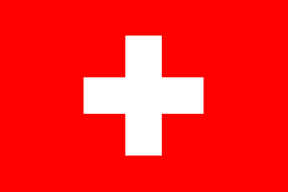
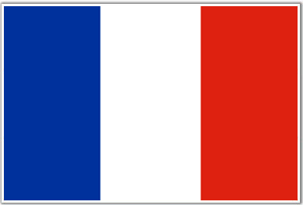
French Flag Japanese Flag Swiss Flag
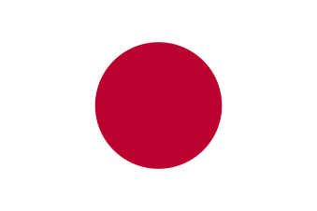

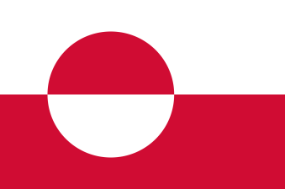
Greenland Flag Peace Flag Custom Flag
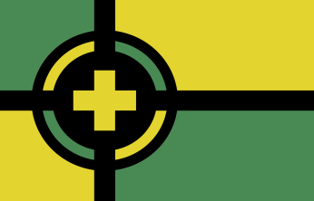

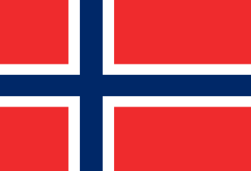
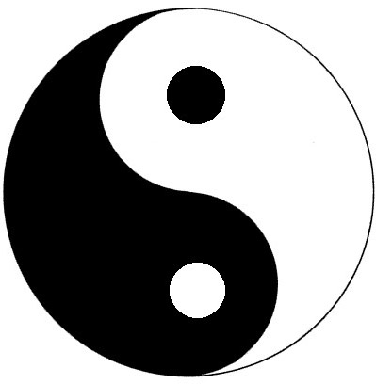
Norway Flag Yin Yan Symbol Flag Create Your Own
???

