Computer Programming - Shooter Program - 25 Points
This program allows you to move a character around the form and shoot a bullet in whatever direction you are facing. You can only shoot one bullet at a time. Once the bullet leaves the form, you are allows to shoot again.
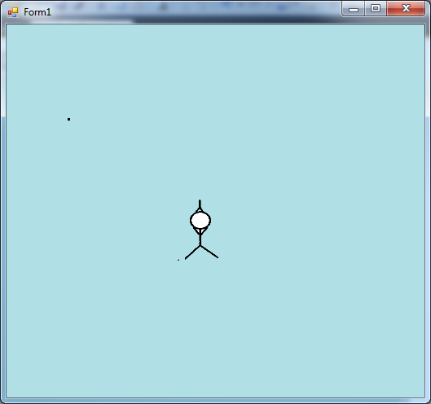
Part I. The Form

bullet(Label) shooter (PictureBox)

bullet Properties: Size (3, 3) Shooter Properties - Sizemode - StretchImage Size (50,75)

All images are found on the share drive in the Computer Programming\Images\Timer Images folder. They are called stickup, stickdown, stickleft and stickright.png.

You also need a Timer object with the following property settings:
name: BulletTimer Enabled - False Interval - 10

Part II. Variables
Dim dir As String = "up" 'Controls the direction the player is facing
Dim bulletDir As String 'Controls the direction the bullet is traveling

Part III. Events and Code

Private Sub Form1_KeyDown(sender As Object, e As System.Windows.Forms.KeyEventArgs) Handles Me.KeyDown
If e.KeyCode = Keys.W Then
shooter.Location = New Point(shooter.Location.X, shooter.Location.Y - 5)
shooter.Image = Image.FromFile("stickup.png")
dir = "up"
ElseIf e.KeyCode = Keys.S Then
shooter.Location = New Point(shooter.Location.X, shooter.Location.Y + 5)
shooter.Image = Image.FromFile("stickdown.png")
dir = "down"
ElseIf e.KeyCode = Keys.A Then
shooter.Location = New Point(shooter.Location.X - 5, shooter.Location.Y)
shooter.Image = Image.FromFile("stickleft.png")
dir = "left"
ElseIf e.KeyCode = Keys.D Then
shooter.Location = New Point(shooter.Location.X + 5, shooter.Location.Y)
shooter.Image = Image.FromFile("stickright.png")
dir = "right"
ElseIf e.KeyCode = Keys.Space Then
shoot()
End If
End Sub

Public Sub shoot()
If bulletTimer.Enabled = False Then
bulletDir = dir
If bulletDir = "left" Then
bullet.Location = New Point(shooter.Location.X, shooter.Location.Y + 28)
End If
If bulletDir = "right" Then
bullet.Location = New Point(shooter.Location.X + shooter.Size.Width, shooter.Location.Y + 28)
End If
If bulletDir = "up" Then
bullet.Location = New Point(shooter.Location.X + shooter.Size.Width / 2, shooter.Location.Y)
End If
If bulletDir = "down" Then
bullet.Location = New Point(shooter.Location.X + shooter.Size.Width / 2 - 2, shooter.Location.Y + shooter.Size.Height)
End If
bulletTimer.Start()
End If
End Sub

Private Sub bulletTimer_Tick(sender As System.Object, e As System.EventArgs) Handles bulletTimer.Tick
If bulletDir = "up" Then
bullet.Location = New Point(bullet.Location.X, bullet.Location.Y - 5)
End If
If bulletDir = "down" Then
bullet.Location = New Point(bullet.Location.X, bullet.Location.Y + 5)
End If
If bulletDir = "left" Then
bullet.Location = New Point(bullet.Location.X - 5, bullet.Location.Y)
End If
If bulletDir = "right" Then
bullet.Location = New Point(bullet.Location.X + 5, bullet.Location.Y)
End If
If bullet.Location.X < 0 Or bullet.Location.X > Me.Size.Width Or bullet.Location.Y < 0 Or bullet.Location.Y > Me.Size.Height Then
bulletTimer.Stop()
End If
End Sub

The idea behind the program is that when the spacebar is pressed the direction of the bullet is set to the direction of the shooter and also positioned appropriately based on the direction. The timer is started, which moves the bullet until it leaves the form, at which time the timer is stopped.
