Power Supply Notes
- Watts - Maximum amount of power your power supply can provide
  - Every major component will have a wattage requirement and if your power supply doesn't provide enough, you system may fail to function properly or even turn off or fail to boot.
    - Motherboard
      - Will need either a 20pin or 24 pin power connector
      - 20+4 pin will handle both
    - CPU Power
      - Will need either a 4-pin or 8-pin CPU power connector
      - 4+4 CPU power connector will handle both
    - Graphics card
      - Will take either 6-pin or 8-pin PCI-e power connector
      - 6+2 PCI-e power connector will handle both
  - This is shown on the back of your power supply and will be a number followed by "W"
  - 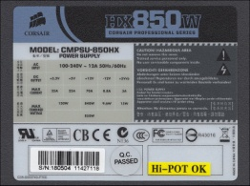 850W means 850 Watt power supply
  - Typically a 500W power supply will handle the needs of even high end computer systems.
  - However, if you make sure of multiple graphics cards, you may need to go higher.
- Modular Cabling
  - Instead of all cables permanently connected to power supply, you can just plug in the ones you need.
  - Eliminates unused cables from congested the inside of your case.
- Form Factor - We have power supplies to fit different case sizes
  - ATX
  - Micro-ATX
  - Mini-ATX (Also called SFX)
- 80 PLUS Certification
  - Must match certain industry guidelines for power efficiency to get this "stamp of approval".
  - Bronze, Silver and Gold levels
- Power Supply Life Expectancy
  - MTBF - Mean Time Between Failure
  - Looks for minimum 100,000 hours.
- Overvoltage Protection
  - If the voltage hits a certain level, the power supply will shut itself off to save internal components.
  - Some cheap power supplies may not have this feature and that is a risk.
- Types of Power Supply Connections

Name | What It Powers | Image
4-pin Berg | Floppy Disk Drives | 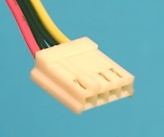
4-pin Molex | Older hard drives and optical drives | 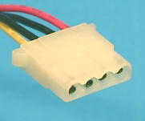
20-pin ATX main power | Older motherboards | 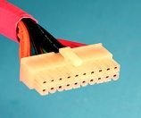
24-pin ATX main power | Newer motherboards | 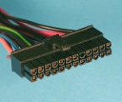
20+4 pin ATX main power | Adaptable to fit new and old motherboards | 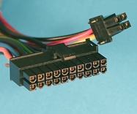
4-pin CPU power | Older, less powerful CPUs | 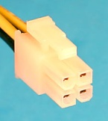
8-pin CPU | Newer CPUs | 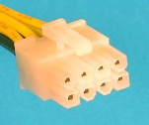
4+4 pin CPU power | Adaptable to fit newer and older CPUs | 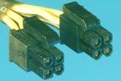
6-pin PCI Express power | older, less powerful video cards | 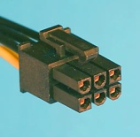
8-pin PCI Express power | newer, more powerful video cards | 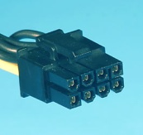
6+2 pin PCI Express Power | Fits both new and old video cards | 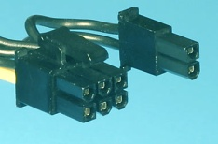
SATA power cable | Fits newer hard drives and optical drives | 