PC Maintenance And Repair - Chapter 1
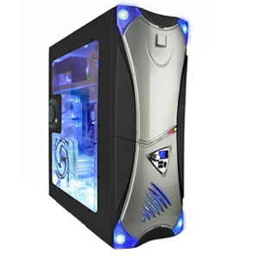
Cases - Know these two types
- Tower Case
- Stands upright
- Has room for several optical and/or hard drives
- Often used for servers
- Larger than desktop
- Easier to upgrade
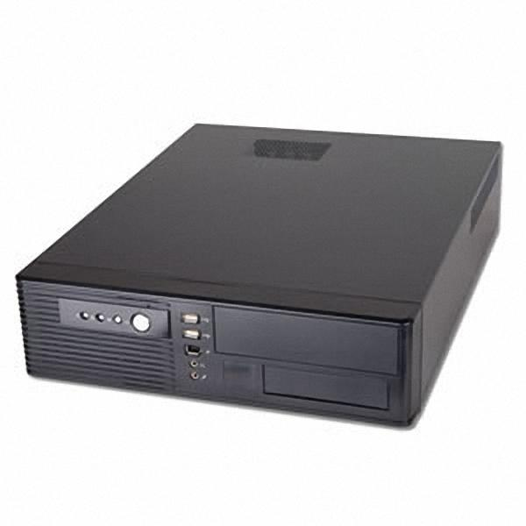
- Desktop Case
- Lies Flat
- Often has a monitor placed on top
- Smaller with less room to work inside
- Less room inside for additional drives/upgrades
Ports - Know these 16 port types by sight and their function
Port Name | Purpose | Image
VGA | Also known as DB-15 port. Used to transmit video from computers to older monitors. | 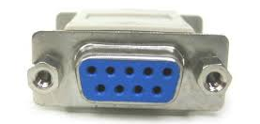
S-Video | Used to connect a computer to a television. Will have either 4 or 7 pins. This typically found in older computers and laptops. | 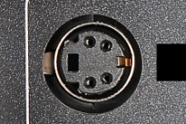
DVI | Transmits video only from PC to monitor. More current than VGA.  Digital Video Interface. There are 3 types which will be discussed later. | 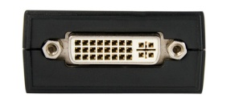
HDMI | Transmits video and audio. Used for computers and home theater equipment. | 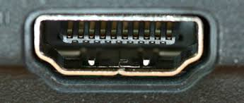
DisplayPort | Transmit video and audio. Slowly replacing DVI. Identified by the "D" symbol shown in the image to the right. | 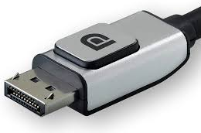
Thunderbolt | Transmits video and data on same port and cable. Shaped the same as DisplayPort and compatible with DisplayPort devices. Identified by lightning bolt symbol shown in image to the right.
Ethernet Port | Used to connect your computer to a network, providing Internet access. | 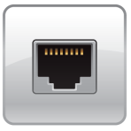
Audio Port | 3 or more round ports used for microphone, audio in, audio out and stereo audio out. If you have one audio cable to connect, use the lime green port. | 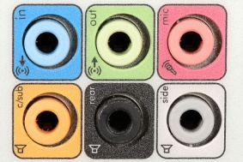
S/PDIF | Sony-Philips Digital Interface sound port - connects to external home theater system, providing best signal quality. Also called optical audio. | 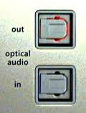
USB | Universal Serial Bus - Multipurpose input/output (i/o) device used to connect mice, keyboard, external drives, scanners, flash drives, etc.. to a computer. There are varying speeds of USB ports. (discussed later) | 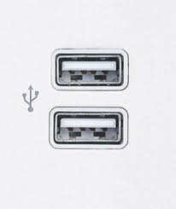
FireWire | Also called IEEE1394. Used to connect high-speed multimedia devices such as digital camcorders. Faster USB ports have made this somewhat obsolete. Note the "Y"-shaped symbol.
external SATA | (aka eSATA) - Used to connect certain external hard drives. It is faster than FireWire. | 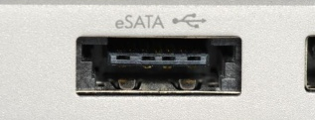
PS/2 | aka mini-DIN port - Round 6-pin ports used by older mice and keyboards. Purple is used for keyboards. Green for mice. Has been replaced by USB ports on newer computers. | 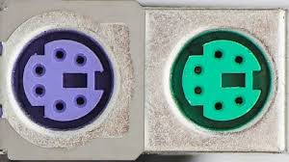
Serial Port | aka DB9 - 9 pin ports used on older computers. Replaced by USB. | 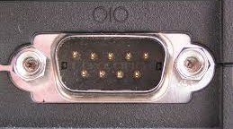
Parallel port | 25 pin port used to connect computers to older printers. Replaced by USB. | 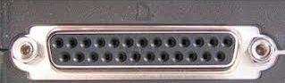
Modem Port | aka RJ-11 - Used to connect dial-up phone lines to computers for dial-up Internet access. Services like America Online used this technology in the 90s. The port look exactly like a telephone jack. It has been replaced by Ethernet ports due to the much faster speeds available.

Motherboards - Know two Form Factors (sizes)
- ATX - Advanced Technology Extended
  - Most common
  - Must buy a case designed to fit an ATX motherboard
  - Larger motherboard with many expansion slots for upgrading
  - Developed by Intel in 1995
- MicroATX
  - Smaller by reducing the number of expansion slots
  - Uses smaller cases than ATX motherboards
  - Less powerful power supply required due to fewer components to "feed"

Power Connectors - Recognize these power connectors by sight and know what they connect to
Power Connector | What it connects to | Image
20-pin P1 | Main power to older motherboards | 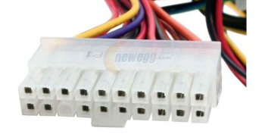
24-pin P1 | Main power to current motherboards | 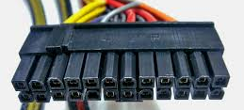
20+4 pin P1 | Main power to older and newer motherboards, by having the extra 4 pins separate from first 20 | 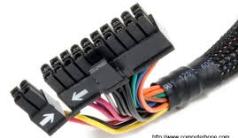
4-pin auxiliary motherboard | Older connector that connects to motherboard but is used to provide power to CPU
8-pin auxiliary motherboard | Two side-by-side 4-pin auxiliary connects used to provide additional power to newer motherboards and CPUs | 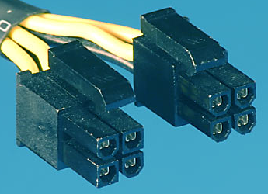
4-pin Molex | Provides power for IDE or PATA drives (older hard drives and CD-ROM drives)
15-pin SATA | Used for SATA drives (newer hard drives and DVD/Blu-Ray optical drives)
4-pin Berg | Used by floppy disk drives (very old) | 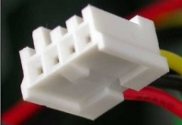
6-pin PCIe | Provides power to PCI Express (version 1) video cards | 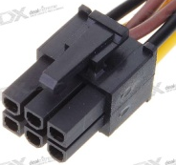
8-pin PCIe | Provides power to PCI Express (Version 2) video cards | 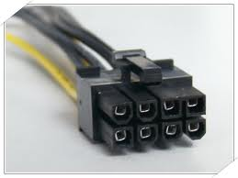
6+2 pin PCIe connector | Provides power to PCI Express video cards. It has the capacity to work with version 1 and version 2, due to having an additional 2 pins

Disk Drives - Know power and connection cable types
- SATA - (Serial ATA)
  - Newer and faster connection for hard drives and optical drives.
  - Uses 15-pin SATA (power) and SATA cable for connecting to motherboard (data)
- PATA - Parallel ATA or IDE
  - Older, slower connection for hard drives and older optical drives (CD-ROM)
  - Uses 4-pin Molex for power
  - Uses 40-pin ribbon cable for connection to motherboard (data)
- EIDE - Enhanced IDE
  - Same as PATA except it uses an 80-pin ribbon cable for connection to motherboard (2x faster)

Floppy Drives - Know power cable and data cable
- Uses 4-pin berg connector for power
- Uses 34-pin ribbon cable connection to motherboard
Electricity Terms
Term | Definition | Units of measure
voltage | How hard the electricity is being pushed through the cable/outlet. Think water pressure in a pipe as voltage | volt (v)
current | Measure how much electricity flows per second | amps (a)
resistance | Measure how much resistance the electricity meets as it moves through a substance. Most computer cables and wires will have near 0 resistance | ohm (Ω)
work | Measures how much work required to push the electricity through to a device. Specifically, the work it takes to push one amp of current through a resistance of 1 ohm is measured as a joule. | joule
power | Measures work over time. One joule per second is a watt. It measures total electrical power required to operate a device. | watt (W)

AC vs. DC
Hot, Neutral and Ground
Protecting Yourself from Electrical Shocks and Burns
Protecting Equipment from ESD
PC Technician Tools

