OSPF Cost Written Assignment - 60 Points
(35 Points for Written, 25 Points – Packet Tracer)
Cost Calculation
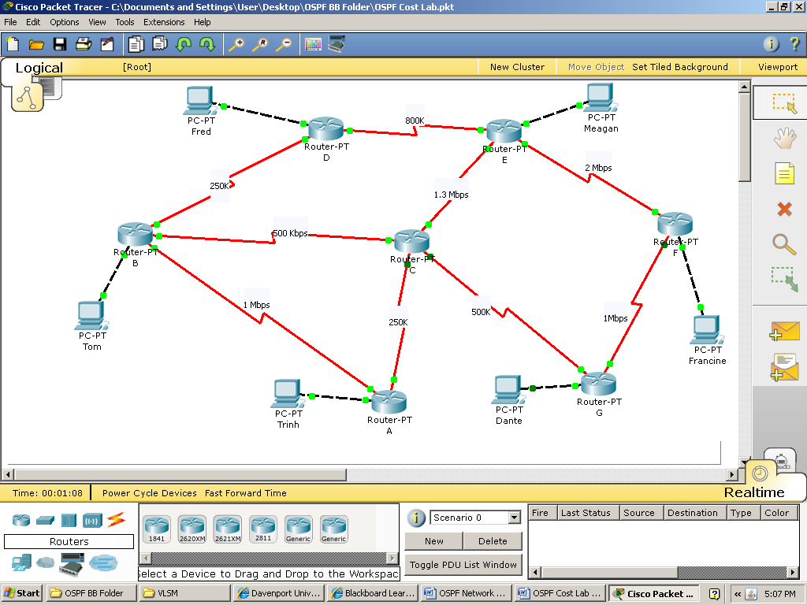

Part I. Possible routes - For each of the following, write down all of the possible routes that could be taken from that router to the end destination. For example, a possible route from Router B to France is BCGF. You must list all of them.
Router B to Francine -

Router D to Dante -

Router F to Fred -

Router A to Meagan -
Part II. Link costs – We need to know what OSPF’s cost will be for each link. Fill in this table with the cost for each link speed in the topology. The formula is 100,000,000 (10⁸)/ bandwidth. You can assume all LANs are 100 Mbps or faster.
Speed | OSPF Cost
72K
128K
250K
500K
800K
1 Mbps
1.3 Mbps
2 Mbps
100 Mbps (LANs) | 1

Part III. Compute costs of possible paths - Time to crunch some numbers. You need to calculate the combine cost to get to the destination network for each possible path and find the lowest.

Router B to Francine
Path | Total Cost | Preferred Path? (yes or no)
BDEF | 575 | No

Router D to Dante
Path | Total Cost | Preferred Path? (yes or no)

Router F to Fred
Path | Total Cost | Preferred Path? (yes or no)

Router A to Meagan
Path | Total Cost | Preferred Path? (yes or no)

Section III – Now configure the topology with OSPF as your routing protocol. Remember the following:
- One network statement for each subnet that the router touches. (per interface, basically)
- BANDWIDTH statements on each serial interface – (clock rate AND non-clock rate)

Once completed, compare your manual calculations with the routing tables. (Your number should be within 1-2)

Does the routing entry in Router B for 199.0.0.80 (Francine’s LAN) match your preferred route cost?

Does the routing entry in Router D for 199.0.0.0 (Dante’s LAN) match your preferred route cost?

Does the routing entry in Router F for 199.0.0.128 (Fred’s LAN) match your preferred route cost?

Does the routing entry in Router A for 199.0.0.96 (Meagan’s LAN) match your preferred route cost?

