AP Computer Science – JUnit Testing
JUnit Testing is a way to test code in a bunch of predetermined conditions. It’s similar to LiveLab, without needing the website. Here’s how it works:
I will give you a class to build and a JUnit Testing Case. You will place both of them in your Java Project. Build the class as you normally would, but with the JUnit test case, you will create JUnit Test Case, not a class. Copy and paste the provided text into each file. The JUnit test case will not be altered in anyway. It is predesigned to check the validity of your class construction. All you have to do is run the JUnit test case like a normal program and it will tell you whether or not the components of your class are working or not.
JUnit Testing Directions
- Create a Java Project called JUnitMethods
- Create a Java Class file called Methods. Copy and paste the code from the weebly into this Java class. There are some unfinished methods that you will need to complete for this to pass the provided JUnit testing.
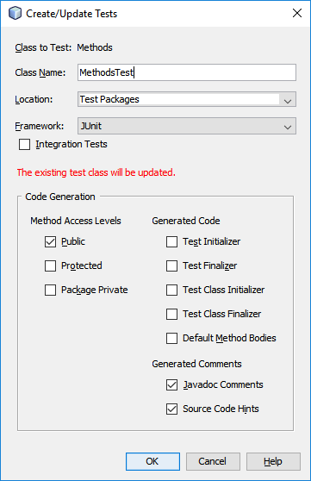
- Create a JUnit test case called MethodsTest. Go to Tools menu and select Create/Update Tests. Now copy and paste the code from the weebly (MethodsTest) into this class. It will most likely create a new folder (Test Packages) for your JUnit tests. No big deal.

- Save everything and right-Click (Run File) on your MethodsTest class. It should run through saying that you passed 0 tests and failed 9. If you fix the methods in the Methods class, these tests will pass when you run MethodsTest. Your goal is to get 100% of the tests to pass. Each methods test has 3 or 4 data sets that it will run.

