Javascript Drawing Test – 100 Points
Directions: You choose 1 image from each category (Easy, Medium, Hard). 10 points of each image is based on your graph paper drawing. Pay close attention to the drawing details. For example, the Olympic Rings (hard) requires you to create the correct overlapping as shown below. Staple your drawings to this document and submit at end of the hour.
Easy Image (33 Points) (Pick one of six) 10 Points – Graph Paper Drawing 23 Points – Javascript Drawing
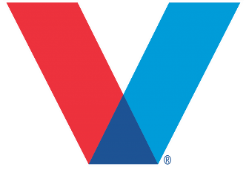
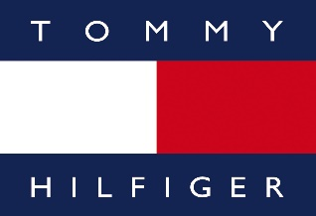
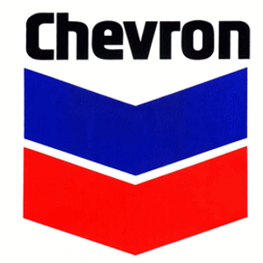

Medium Image (33 Points) (Pick one of eight) 10 Points – Graph Paper Drawing 23 Points – Javascript Drawing
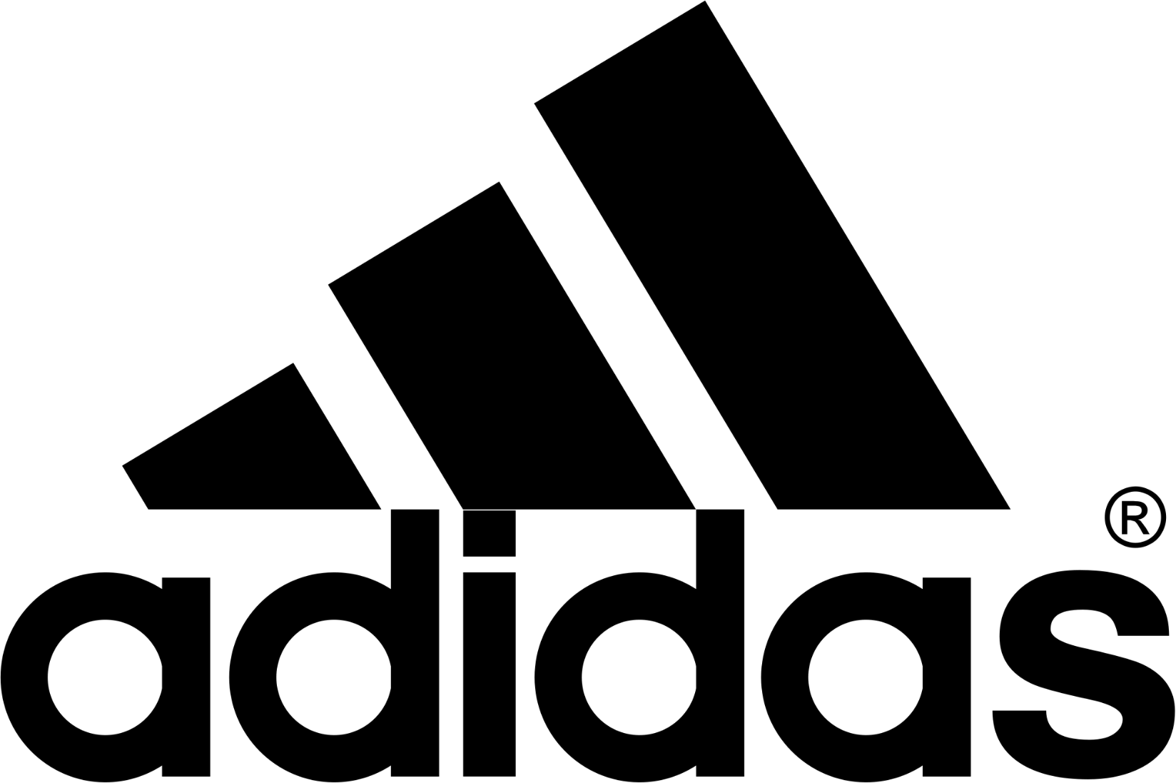
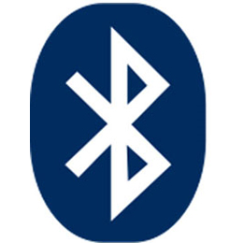
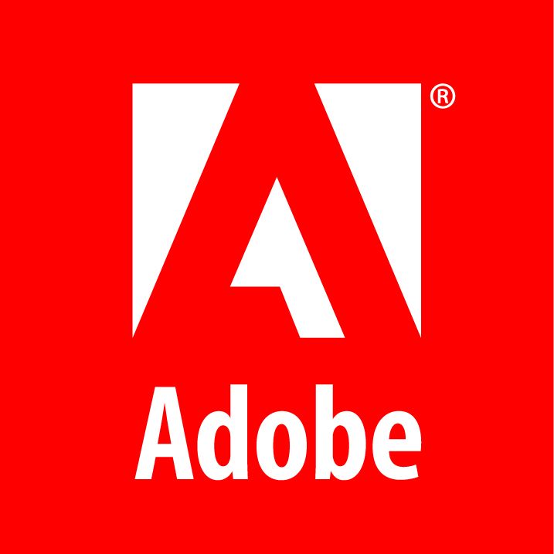

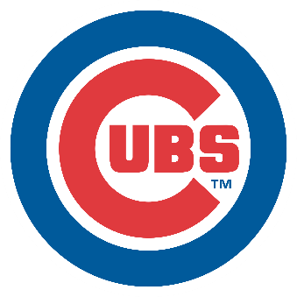
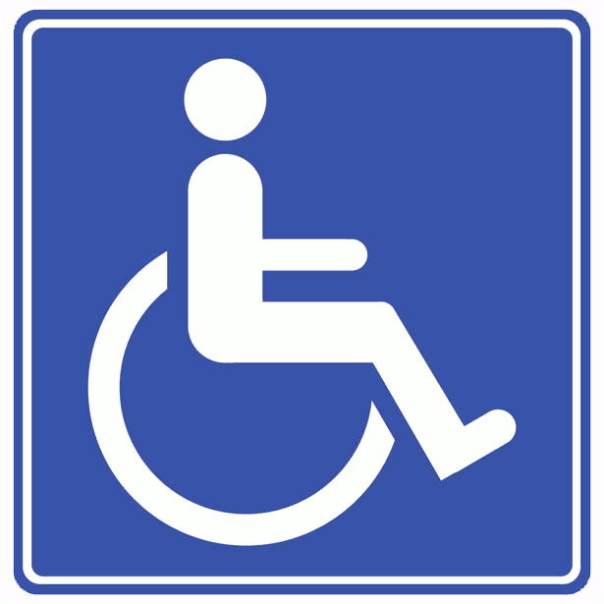
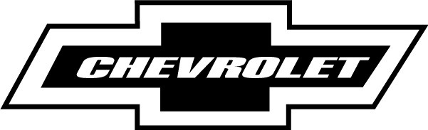

Hard Image (34 Points) (Pick one of five) 10 Points – Graph Paper Drawing 24 Points – Javascript Drawing
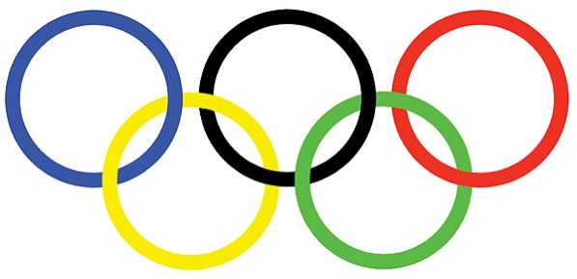
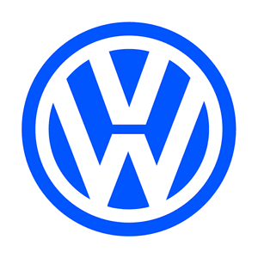

*Note - You can pick your own canvas size, but your javascript drawing commands need to match your graph paper. No sharing your javascript code. Copying code will result in both parties failing the test!

