Exploration of Technology - HTML Assignment # 4 – Elements Website
Directions - This assignment is going to require you to build four different web pages that will be linked together. The topic is going to be on "Interesting Elements". You will have a main page from which you can navigate, using hyperlinks to three additional pages. Here's the layout for the website:
Page # 1 - elements.html
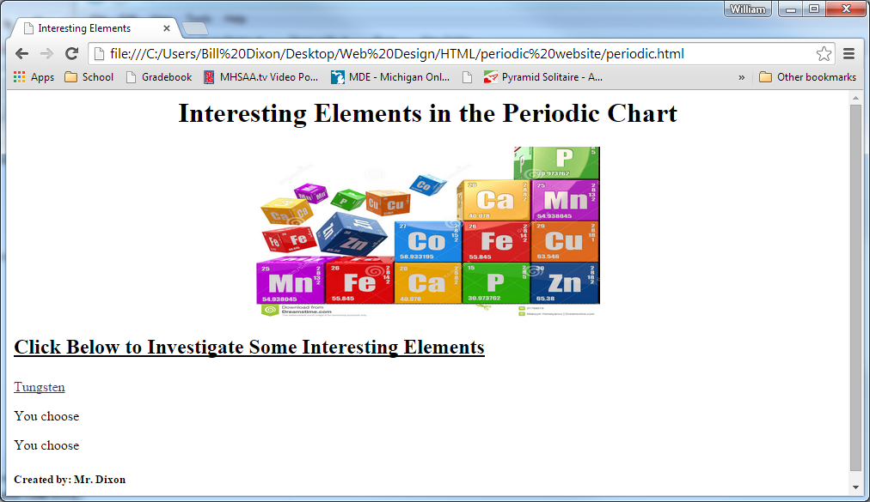
Build your main page in the same format as what you see here. You must choose Tungsten for your first element. The remaining two elements will be your own choice. You should pick a different but thematic image to appear on this page. All other formatting should be consistent with the image seen below (underlining, header tags (h1, h2, etc.), titles> The bottom of the page will include 3 hyperlinks to three additional pages, each devoted to a different element.

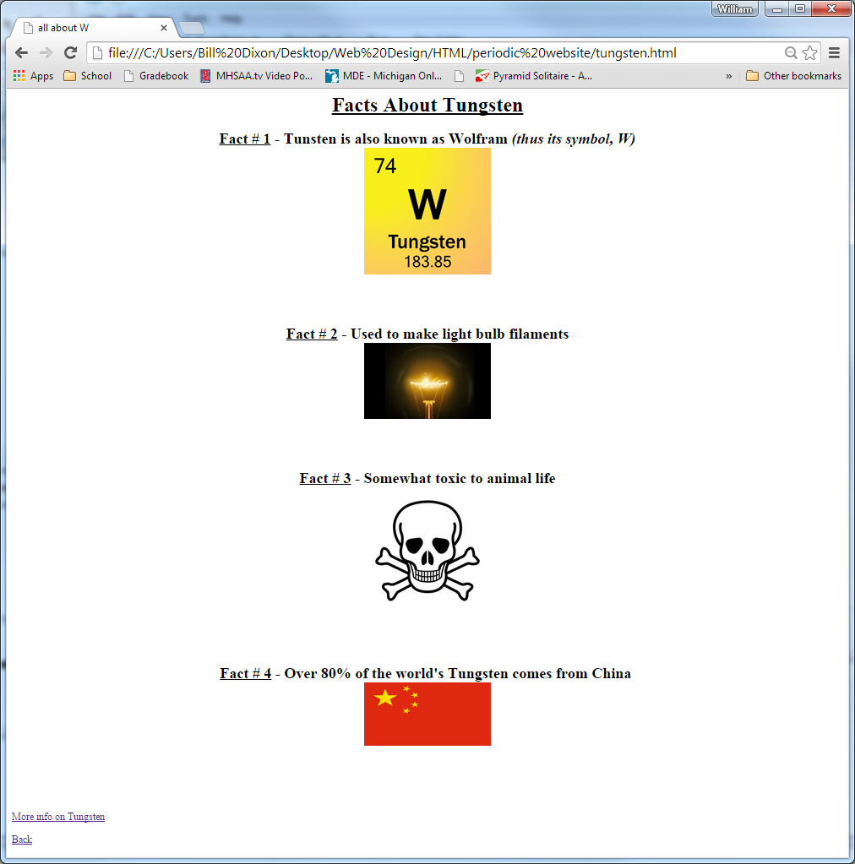
Pages # 2 to 4 - tungsten.html, choice, choice
Tungsten is the first and only required element of the three. It should appear just like what is shown to the right. Four facts about the element, with each accompanied by an appropriate image. Two of the images should be downloaded and loaded directly from your student drive. The other two images should be "hot linked" from an external web page. Each image should be resized to fit properly on the web page.
At the bottom, there should be two hyperlinks. The first will load an external web page with information about that element, such as Wikipedia. The second hyperlink will simply return to the main page. (elements.html)
Be sure to follow consistent formatting on each of these pages.

