**Explorations of Technology - Basic HTML Tag Assignment**

45 Points

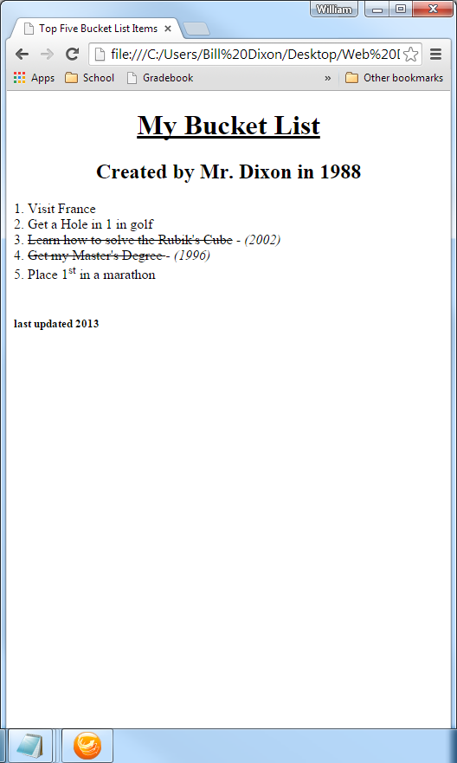

**HTML tags used**

<h1>, <h2>, <h5>

<title>

<center>

<strike>

<sup>

<i>

<u>

<br>

<h5>

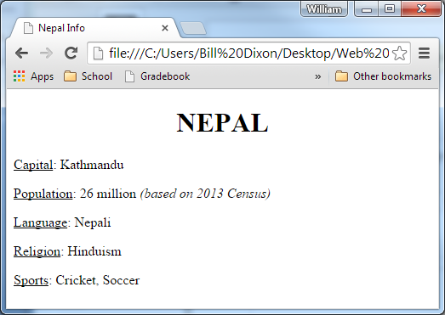

**HTML tags used**

<h1>, <h2>, <h5>

<title>

<center>

<i>

<u>

<br>

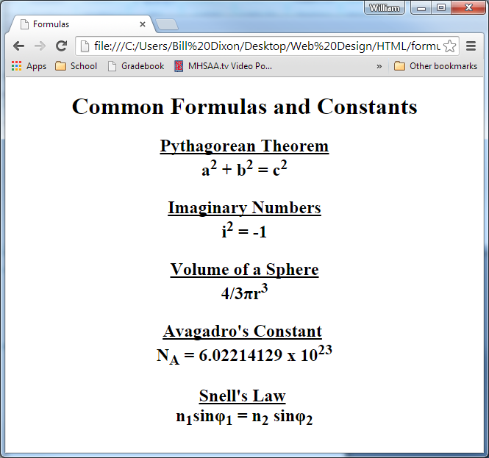

**HTML tags used**

<h1>, <h2>

<title>

<center>

<br>

<b>

<i>

<u>

<sup>

<sub>

*Save with unicode encoding