**HTML - Lists Assignment**

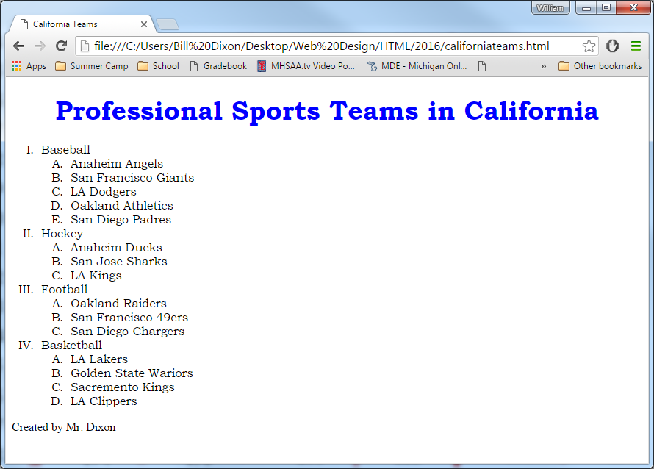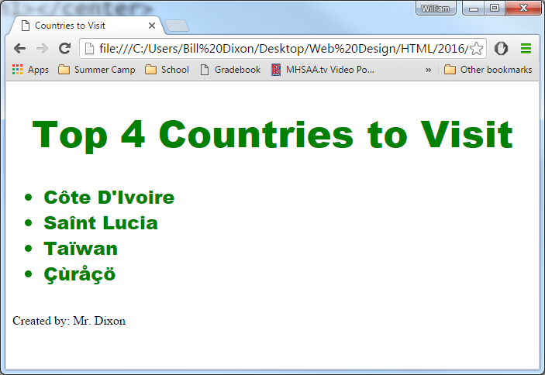

**californiateams.html**

* Nested Ordered List
* Ordered List Types
  + "I" for sports
  + "A" for teams
* Placement of your ending tag is key
* Font is "Bookman Old Style"

**visit.html**

* Font is "Arial Black"
* Watch out for Accent Marks
* www.asciitable.com
* Unicode encoding
* unordered list