Explorations of Technology – Part of the Computer
Directions: For the following 11 terms, you need to do two things. First, you must give the purpose of the computer part. Second, you must find an image (via search engine) of the computer part. The first term is done for you.
Term | Purpose | Image
RAM |  | 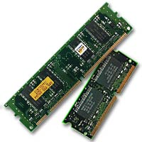
Hard Drive
Optical Drive
CPU
Case
Power Supply
Heat Sink
Motherboard
Floppy Drive
Expansion Bay
Thermal Paste

