Web Development - DIV Assignment
Directions: Create the following webpage layouts using DIV tags. The rules are as follows:
- Your page should be completely covered with the div containers and no gaps between regions.
- There should be no vertical or horizontal scroll bars appearing, indicating that your <div> containers perfectly fill your browser window.
- All areas should percentages for width, height, left and right properties.
- The ID should simply be the letters A-?, based on the number of regions.
- The text in each div should simply be the letter of the ID and colors should be in rainbow order: ROYGBIV.
- You can use overlapping <div> tags to create the desired affect.
- Your HTML page will look like this. You need only add the <div> tags for the number of regions in the page.
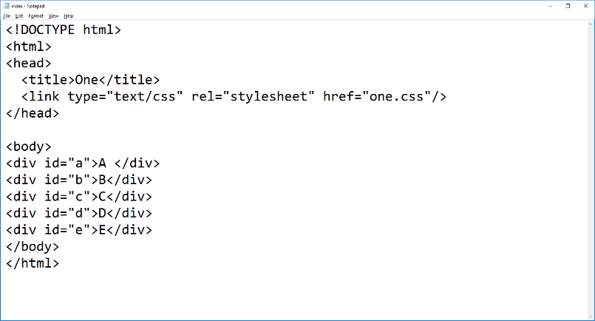

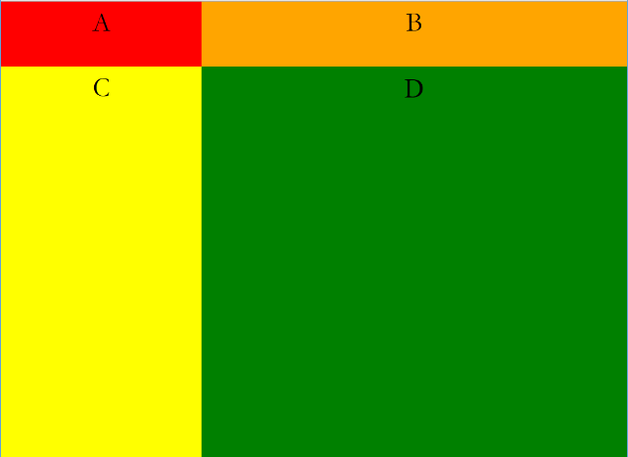
one.css two.css
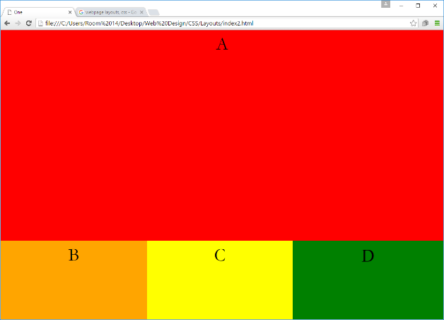

three.css four.css
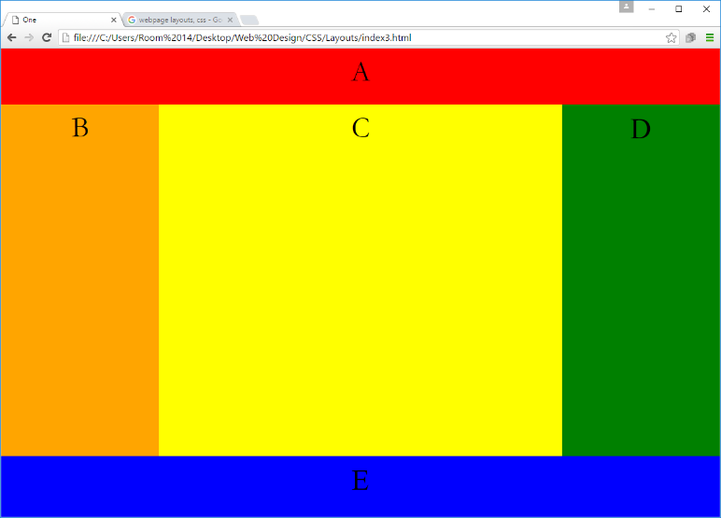
Create your own layout:
- Must have at least six regions
- No scroll bars
- Balance regions vertically and horizontally
- No “white” showing
- Should work, even if window is resized

