Computer Programming – Final Exam Review Code

ReviewAge

Public Class Form1
Dim n As String 'name
Dim a As Integer 'age
Private Sub Button1_Click(sender As Object, e As EventArgs) Handles Button1.Click
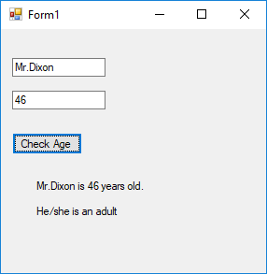
n = TextBox1.Text
a = TextBox2.Text
Label1.Text = n & " is " & a & " years old."
If a < 18 Then
Label2.Text = "He/she is a minor"
End If
If a >= 18 And a <= 65 Then
Label2.Text = "He/she is an adult"
End If
If a > 65 Then
Label2.Text = "He/she is a senior citizen."
End If
End Sub
End Class

ReviewDrawing

Public Class Form1
Private Sub Form1_Paint(sender As Object, e As PaintEventArgs) Handles Me.Paint
Dim g As System.Drawing.Graphics
g = Me.CreateGraphics
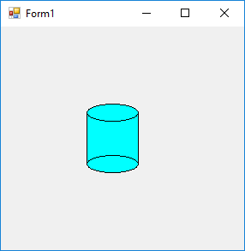
Dim p As New Pen(Color.Black, 2)
Dim blueBrush As New SolidBrush(Color.Cyan)

g.FillRectangle(Brushes.Cyan, 100, 100, 60, 60)
g.DrawRectangle(Pens.Black, 100, 100, 60, 60)
g.FillEllipse(Brushes.Cyan, 100, 90, 60, 20)
g.DrawEllipse(Pens.Black, 100, 90, 60, 20)
g.FillEllipse(Brushes.Cyan, 100, 150, 60, 20)
g.DrawEllipse(Pens.Black, 100, 150, 60, 20)

End Sub
End Class

ReviewRainbow

Public Class Form1
Private Sub Button1_Click(sender As Object, e As EventArgs) Handles Button1.Click
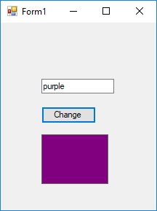
If TextBox1.Text = "purple" Then
Label1.BackColor = Color.Purple
End If
If TextBox1.Text = "orange" Then
Label1.BackColor = Color.Orange
End If
End Sub
End Class

ReviewScreenSaver

Public Class Form1
Dim hdir As String = "right"
Dim vdir As String = "up"

Private Sub Timer1_Tick(sender As Object, e As EventArgs) Handles Timer1.Tick
If hdir = "right" Then
box.Location = New Point(box.Location.X + 5, box.Location.Y)
End If
If hdir = "left" Then
box.Location = New Point(box.Location.X - 5, box.Location.Y)
End If
If vdir = "up" Then
box.Location = New Point(box.Location.X, box.Location.Y - 5)
End If
If vdir = "down" Then
box.Location = New Point(box.Location.X, box.Location.Y + 5)
End If
'check top
If box.Location.Y = 0 Then
vdir = "down"
End If
'check left
If box.Location.X = 0 Then
hdir = "right"
End If
'check right side
If box.Location.X = 280 Then
hdir = "left"
End If
'check bottom
If box.Location.Y = 380 Then
vdir = "up"
End If
End Sub
End Class

ReviewSumItUp

Public Class Form1
Dim num, sum, x As Integer
Private Sub Button1_Click(sender As Object, e As EventArgs) Handles Button1.Click
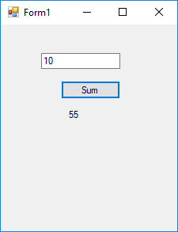
sum = 0
num = TextBox1.Text
If num <= 0 Then
MsgBox("Enter a positive number")
Else
For Me.x = 1 To num
sum = sum + x
Next
label1.text = sum
End If
End Sub
End Class

ReviewAddition

Public Class Form1
Dim num1, num2, answer As Integer

Private Sub Form1_Load(sender As Object, e As EventArgs) Handles MyBase.Load
makeQuestion()
End Sub

Private Sub Button1_Click(sender As Object, e As EventArgs) Handles Button1.Click

answer = TextBox1.Text
If answer = num1 + num2 Then
MsgBox("correct")
Else
MsgBox("Wrong. The right answer is " & (num1 + num2))
End If
makeQuestion()
End Sub
Public Sub makeQuestion()
Randomize()
TextBox1.Text = ""
num1 = Int(Rnd() * 10) + 1
num2 = Int(Rnd() * 10) + 1
Label1.Text = num1 & " + " & num2 & " = ?"
End Sub
End Class

ReviewTriangle

Public Class Form1
Dim hdir As String = "right"
Dim vdir As String = "down"

Private Sub Timer1_Tick(sender As Object, e As EventArgs) Handles Timer1.Tick
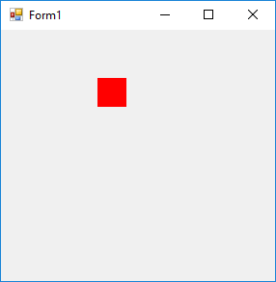
If hdir = "right" Then
box.Location = New Point(box.Location.X + 5, box.Location.Y)
End If
If hdir = "left" Then
box.Location = New Point(box.Location.X - 5, box.Location.Y)
End If
If vdir = "up" Then
box.Location = New Point(box.Location.X, box.Location.Y - 5)
End If
If vdir = "down" Then
box.Location = New Point(box.Location.X, box.Location.Y + 5)
End If
'starts at 100, 50 (down and right)
'turn left at 150, 100
'50, 100 - turn up and right

If box.Location.X = 150 And box.Location.Y = 100 Then
hdir = "left"
vdir = "nothing"
End If
If box.Location.X = 50 And box.Location.Y = 100 Then
hdir = "right"
vdir = "up"
End If
If box.Location.X = 100 And box.Location.Y = 50 Then
hdir = "right"
vdir = "down"
End If
End Sub
End Class

ReviewCat

Public Class Form1
Dim b As Button
Dim l1, l2, l3, l4, l5, l6, l7, l8, l9 As Label

Private Sub Form1_Load(sender As Object, e As EventArgs) Handles MyBase.Load
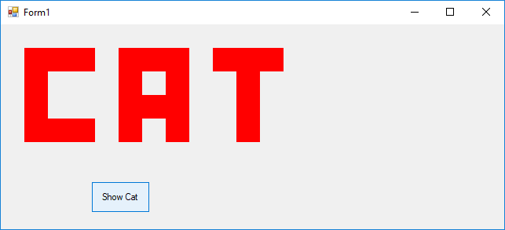
b = New Button
b.Size = New Size(75, 40)
b.Location = New Point(115, 200)
b.Text = "Show Cat"
Controls.Add(b)
AddHandler b.Click, AddressOf showCat
End Sub
Public Sub showCat(ByVal sender As Object, ByVal e As EventArgs)
'use L1, L2, L3 for the C
l1 = New Label
l1.BackColor = Color.Red
l1.Size = New Size(90, 30)
l1.Location = New Point(30, 30)
Controls.Add(l1)

l2 = New Label
l2.BackColor = Color.Red
l2.Size = New Size(30, 60)
l2.Location = New Point(30, 60)
Controls.Add(l2)

l3 = New Label
l3.BackColor = Color.Red
l3.Size = New Size(90, 30)
l3.Location = New Point(30, 120)
Controls.Add(l3)

'A
l1 = New Label
l1.BackColor = Color.Red
l1.Size = New Size(90, 30)
l1.Location = New Point(150, 30)
Controls.Add(l1)

l1 = New Label
l1.BackColor = Color.Red
l1.Size = New Size(30, 120)
l1.Location = New Point(150, 30)
Controls.Add(l1)

l1 = New Label
l1.BackColor = Color.Red
l1.Size = New Size(30, 120)
l1.Location = New Point(210, 30)
Controls.Add(l1)

l1 = New Label
l1.BackColor = Color.Red
l1.Size = New Size(30, 30)
l1.Location = New Point(180, 90)
Controls.Add(l1)

'T
l1 = New Label
l1.BackColor = Color.Red
l1.Size = New Size(90, 30)
l1.Location = New Point(270, 30)
Controls.Add(l1)

l1 = New Label
l1.BackColor = Color.Red
l1.Size = New Size(30, 90)
l1.Location = New Point(300, 60)
Controls.Add(l1)
End Sub

End Class

