Computer Programming - Shapes Assignment
In this assignment, you are going to create 5 different programs, each of which requires you to use different formulae to calculate various values for each shape type. All variables used should be declared as Double, which will give us the ability to use floating point values (numbers with decimals).

*In all formulas, we want to have the output rounded off to three decimal places before being outputted.
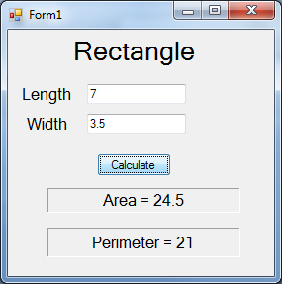
Program # 1 - Rectangle - 6 Points
L is the length of rectangle and W is the width.
Perimeter = 2W +2L
Area = L * W
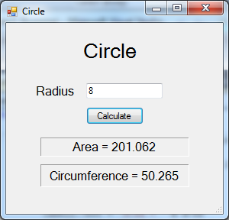
Program # 2 - Circle - 6 Points
r is the radius of the circle
Circumference = 2 $π$r
Area of Circle = $πr^{2}$

Program # 3 - Pythagorean - 10 Points
a² + b² = c²
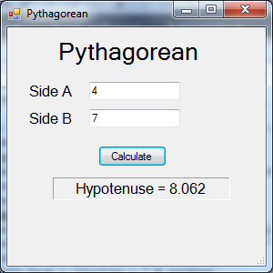
where a and b are the two shorter sides
of a right triangle and c is the hypotenuse.

Program # 4 - Sphere - 8 Points
r is the radius of the sphere
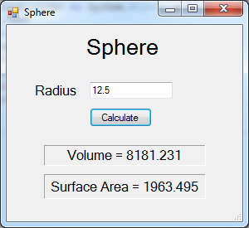
Volume of Sphere = $\frac{4}{3}$πr³
Surface Area of Sphere = 4πr²

Program # 5 - Polygon - 15 Points
s is the side length
n is the number of sides

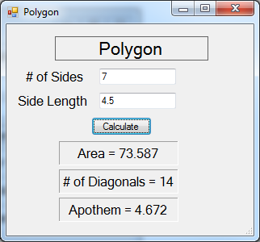
Area = $\frac{s^{2}*n}{4*Tan(\frac{180}{n} *\frac{π}{180})}$

Number of Diagonals = $\frac{n(n-3)}{2}$

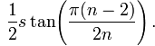
Apothem =

