Computer Programming – Colleges Assignment – 20 Points
Design Phase
You will be creating a design similar to the one seen below. However, you will be choosing your own collection of five colleges for your program. Be sure to follow these directions:
- Your design will contain five buttons and 3 labels
- The buttons should contain the full name of the colleges that you choose.
- The backcolor and forecolor properties of the buttons should match the college’s colors.
- The two labels on the bottom should have the following properties changed to make them appear like what you see below: Autosize, Backcolor, BorderStyle, ForeColor, Font, Text, TextAlign
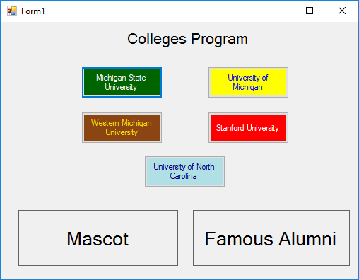
- The Label at the top of the Form is simply there to display the name of the program. It will not be involved in any of the coding or events.

Program Appearance at Start

Coding Phase
When the programming is running, whenever a button is clicked upon, six things should happen:
- The “mascot” Label will have its text changed to the mascot of that college.
- The Backcolor of the “mascot” Label will be changed to one of the two college colors.
- The Forecolor of the “mascot” Label will be changed to the other college color.
- The “alumni” Label will have its text changed to the name of a famous graduate of that college.
- The Backcolor of the “alumni” Label will be changed to the same as the Forecolor of the mascot Label.
- The Forecolor of the “alumni” Label will be changed to the same as the Backcolor of the mascot Label.
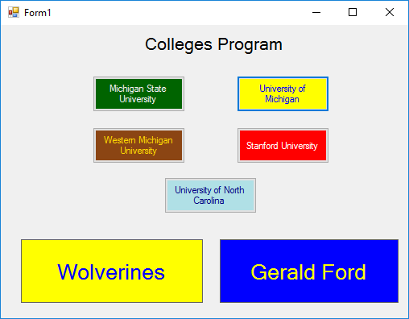

Program appearance after “University of Michigan”
Button is clicked:

All five buttons should work for full credit.

Extra credit:
- Have the colors reverse when you mouseover/mouseleave the mascot and alumni labels
- Try to use different Fonts for different colleges. Check coding sheet for font syntax.

