Computer Programming - Breakout Project – Phase 1 – 50 Points

You will be building classic arcade game, Breakout. This program will be built from code only.
Phase 1 - Graph Paper Design Phase
Do not attempt to write any code before you first create it on graph paper!
This board is built with 107 different objects.
- 98 different labels for the blocks in the alien
- 4 labels for the Score and high score above
- 5 picture boxes for the three walls, the paddle and the ball.
Your first task is to reproduce, on graph paper, the breakout game board seen below. Follow these suggestions:
- Each square in the graph paper will represent a 20 x 20 pixel area of the form.
- The size of the form is going to 616 pixels wide by 720 tall. (600 x 680 viewable) That is 30 x 34 graph paper blocks in size. You can fit this entire design on a single piece of graph paper.
- The top wall should start 3 blocks, or 60 pixels from the top of the form.
- The left wall and right walls should be 20 pixels wide and run from the top wall to the bottom of the visible form.
- Each of the 98 blocks in the alien will be 40 pixels wide by 20 pixels tall. The first column of blocks should start 80 pixels (2 graph paper blocks) from the left edge of the form and the last column of blocks should start 80 pixels from the right edge of the form.
- Be sure to number all of your blocks (labels) 1 to 98 on your graph paper. Start the number on the top of the first column and count down. If this is done correctly, the first block in the second column should be number 7. Continue numbering in this fashion until the last block is numbered 98.
- Any block that is not grey, should have an additional letter: R for Red or Y for Yellow on your graph paper.
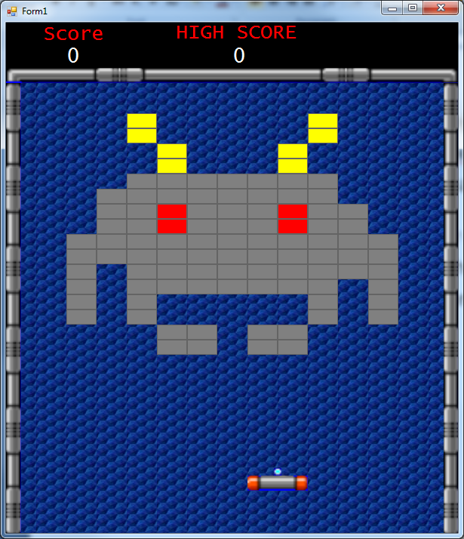
- The paddle size is 80 x 20. The ball is 10 x 10.
- The paddle should be centered horizontally and be positioned 80 pixels above the viewable bottom of the form.
- The ball should be centered on the paddle and be resting on top of it.

